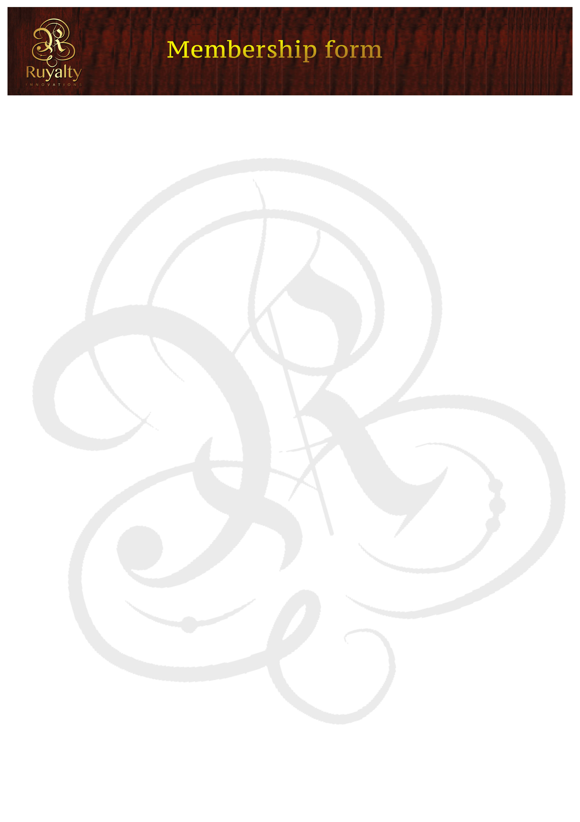

Welcome to ruyaltyinnovations.co.za. This membership form indicates that you would like to become a member and take part in the idea auction bidding process.

Date:

Name of company:

Type of Business:

Preferred email address:

Contact numbers:

Notify me when there’s an idea for my category | YES/NO

*PLEASE NOTE THAT AFTER RECEIVING AN EMAIL NOTIFICATION ABOUT AN IDEA AUCTION FOR YOUR CATEGORY, YOU HAVE 7 (SEVEN) WORKING DAYS TO REQUEST A PRESENTATION, FREE OF CHARGE. OUR AFFILIATED MARKETING AGENCY WILL COMPILE A DETAILED PRESENTATION OF THE IDEA TO COME AND PRESENT TO YOU, IN ORDER TO GET THOROUGH EXPLANANTION OF THE IDEA BEING PRESENTED, THERE WILL BE A QUESTIONS AND ANSWERS SESSIONS. THIS WILL HELP GET A BETTER UNDERSTANDING OF WHAT YOU ARE BIDDING FOR.

*SEE BELOW*
AGREEMENTS
THE FOLLOWING IS A LIST OF AGREEMENTS THAT INDICATES THE FOLLOWING:
- After winning the bid, bidders will receive a confirmation letter indicating that they have won the bid and that letter must be signed and returned back. And must pay within 48 hours in full. (unless arrangements were made)
- Once bidders win the bid, they must pay within the agreed period, failure to do so will lose the idea to the runner up.
- If you replicate or steal an idea posted at ruyaltyinnovations.co.za, you will be taken to court for fraud and thieving of ruyaltyinnovations.co.za intellectual property.
- Bidders must make sure that they understand the idea that they are bidding for, we have a no return policy.
- Bidders will not talk directly to creatives but through ruyaltyinnovations (Pty) Ltd.

I , of (name of company) agree with the stipulations and I will be held had responsible for any infringement of the agreement.

Signature: .

