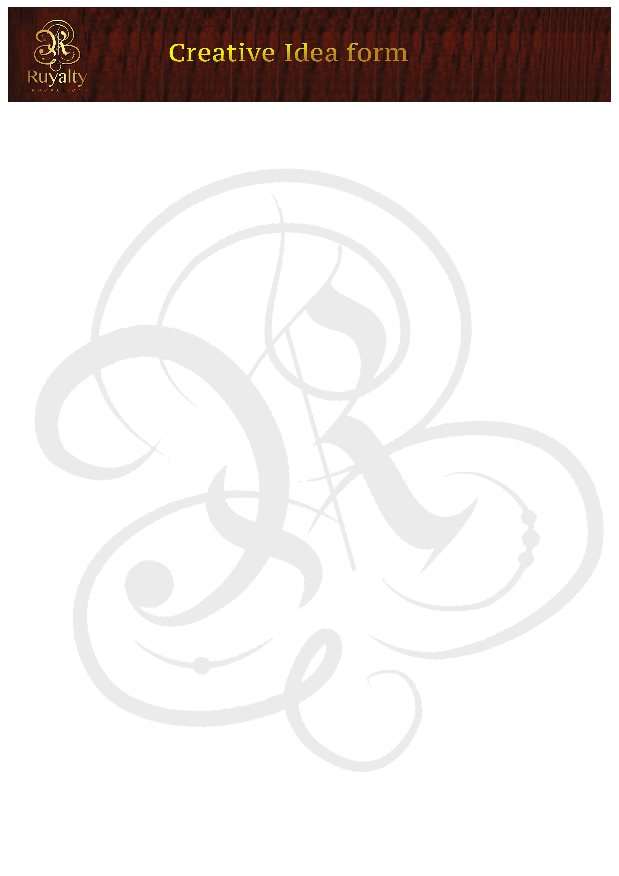
Creative Idea form
Date
Name and Surname
Address
Contact details | Cell:  Email:
Title of Idea
Category of Idea: (e.g. Insurance/ Banking/ etc)
IDEA RATIONALE/ SYNOPSIS .

AGREEMENT FORM
FOR SECURITY PURPOSES, PLEASE TRADEMARK YOUR IDEA BEFORE YOU SEND TO US!!!
All ideas must be sent to screening@ruyaltyinnovations.co.za
- AFTER SENDING YOUR IDEA TO RUYALTY INNOVATIONS, YOU WILL RECEIVE AN EMAIL INDICATING THAT YOUR IDEA HAS BEEN RECEIVED.
- ONCE YOUR IDEA HAS BEEN RECEIVED, IT WILL GO THROUGH 7 (SEVEN) WORKING DAYS SCREENING TO SEE IF IT HAS BEEN DONE BEFORE LOCALLY AND INTERNATIONALLY OR IF IT’S WORTH AUCTIONING.
- IF YOUR IDEA ALREADY EXISTS, YOU WILL GET AN EMAIL FROM screening@ruyaltyinnovations.co.za INFORMING YOU WHY YOUR IDEA COULDN’T BE POSTED.
- IF YOUR IDEA GOES THROUGH, YOU WILL BE NOTIFIED TO LOGIN AND SEE HOW IT IS DOING AT THE AUCTION.
Once the idea has been sold, Ruyalty Innovations will have A 45% of the auction profit and the rest will be sent to you 48hrs after the client has paid.
If you agree please fill in the information below and email back to
screening@ruyaltyinnovations.co.za
I . hereby agree that my idea will be auctioned at ruyaltyinnovations.co.za and I take full responsibility of my idea. I also agree with the terms and conditions stated above.

Signature. .
Thank you, we wish you all the best.
Good Luck .

(If you have any questions regarding this form, please contact yourboss@ruyaltyinnovations.co.za or call
0762152798)

AGREEMENT FORM
FOR SECURITY PURPOSES, PLEASE TRADEMARK YOUR IDEA BEFORE YOU SEND TO US!
All ideas must be sent to screening@ruyaltyinnovations.co.za
- The idea you send to RuyatyInnovations has not been previously seen by any client or organization.
- AFTER SENDING YOUR IDEA TO RUYALTY INNOVATIONS, YOU WILL RECEIVE AN EMAIL INDICATING THAT YOUR IDEA HAS BEEN RECEIVED.
- ONCE YOUR IDEA HAS BEEN RECEIVED, IT WILL GO THROUGH 7 (SEVEN) WORKING DAYS SCREENING TO SEE IF IT HAS BEEN DONE BEFORE LOCALLY AND INTERNATIONALLY OR IF IT’S WORTH AUCTIONING.
- IF YOUR IDEA ALREADY EXISTS, YOU WILL GET AN EMAIL FROM screening@ruyaltyinnovations.co.za INFORMING YOU WHY YOUR IDEA COULDN’T BE POSTED.
- IF YOUR IDEA GOES THROUGH, YOU WILL BE NOTIFIED TO LOGIN AND SEE HOW IT IS DOING AT THE AUCTION.
Once the idea has been sold, Ruyalty Innovations will have 45% of the auction profit and the rest will be sent to you 48hrs after the client has paid.
If you agree please fill in the information below and email back to
screening@ruyaltyinnovations.co.za
I . hereby agree that my idea will be auctioned at ruyaltyinnovations.co.za and I take full responsibility of my idea. I also agree with the terms and conditions stated above.
Signature. .
Thank you, we wish you all the best.
Good Luck .
(If you have any questions regarding this form, please contact yourboss@ruyaltyinnovations.co.za or call: 0762152798)

